Project Design Phase-II Technology Stack (Architecture & Stack)

Technical Architecture:
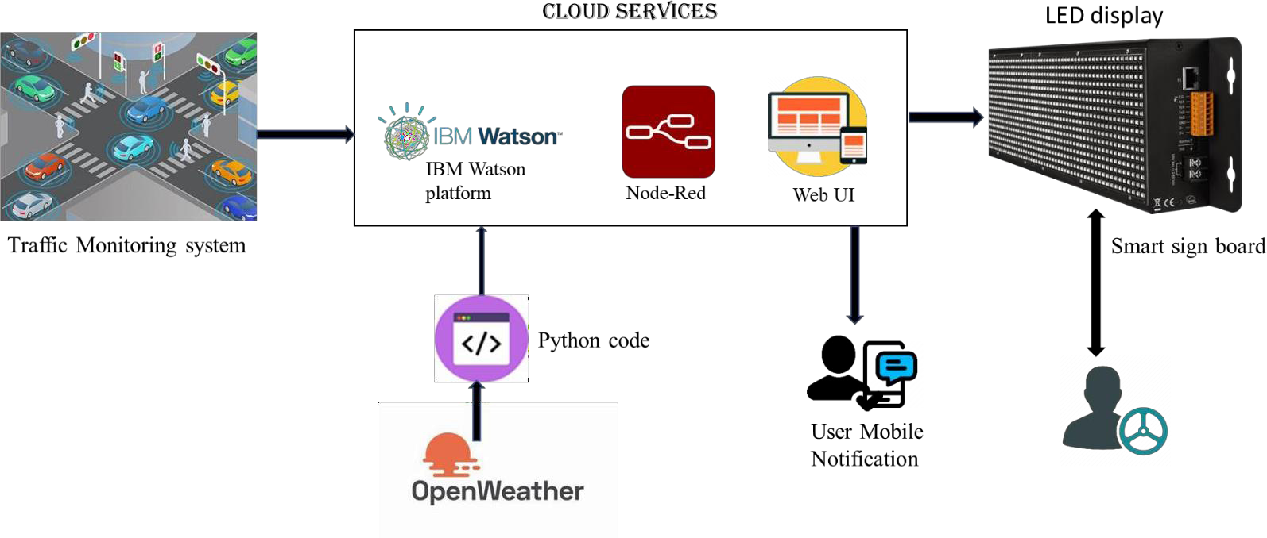
The Deliverable shall include the architectural diagram as below and the information as per the table1 & table 2
Date | 25 October 2022
Team ID | PNT2022TMID44492
Project Name | Signs With Smart Connectivity for Better Road Safety
Maximum Marks | 4 Marks
S.No | Component | Description | Technology
1. | User Interface | How user interacts with application e.g. Web UI, Mobile App, Chatbot etc. | HTML, CSS, JavaScript / Angular Js / React Js etc.
2. | Application Logic-1 | Logic for a process in the application | Java / Python
3. | Application Logic-2 | Logic for a process in the application | IBM Watson STT service
4. | Application Logic-3 | Logic for a process in the application | IBM Watson Assistant
5. | Database | Data Type, Configurations etc. | MySQL, NoSQL, etc.
GUIDELINES:
• To replace the static signboards, smart connected sign boards are used.
• These smart connected sign boards get the speed limitations from a web app using weather API and update automatically.
• Based on the weather changes the speed may increase or decrease.
• Based on the traffic and fatal situations the diversion signs are displayed.
• Guide(Schools), Warning and Service(Hospitals, Restaurant) signs are also displayed accordingly.
• Different modes of operations can be selected with the help of buttons.

Table-1 : Components & Technologies:

Table-2: Application Characteristics:
6. | Cloud Database | Database Service on Cloud | IBM DB2, IBM Cloudant etc.
7. | File Storage | File storage requirements | IBM Block Storage or Other Storage Service or Local Filesystem
8. | External API-1 | Purpose of External API used in the application | IBM Weather API, etc.
S. No | Characteristics | Description | Technology
1. | Security Implementations | Strong security system that anyone without login credentials  and hackers are not allowed to enter the network. | Firewall,  Firebase, cyber resiliency  strategy
2. | Scalable Architecture | Easy to expand the operating range by increasing the bandwidth of the network. | IoT, internet.
3. | Availability | Available anytime and everywhere 24/7 as long as the user is signed into the network. | IBM Cloud
4. | Performance | Supports a large number of users to  access the technology simultaneously. | IBM cloud

